Q1. Identify Skewness using Violin Plots
Aim
To identify the skewness of different datasets using violin plots and determine the relationship between the mean and median.
R Program
The image provides the violin plots but not the original raw data, so the following program uses representative values to demonstrate the same type of visualization.
library(ggplot2)

data <- data.frame(
Group = c(
rep("Zone W", 10),
rep("Zone E", 10),
rep("Zone C", 10)
),
Value = c(
25,35,40,45,50,52,55,60,70,78,
40,60,70,75,78,80,82,83,84,85,
10,12,15,18,20,22,25,30,40,60
)
)

ggplot(data, aes(x = Group, y = Value, fill = Group)) +
geom_violin() +
stat_summary(
fun = median,
geom = "point",
shape = 21,
fill = "white"
) +
labs(
title = "Delivery Time",
x = "Zone",
y = "Delivery Time (minutes)"
) +
theme_minimal()
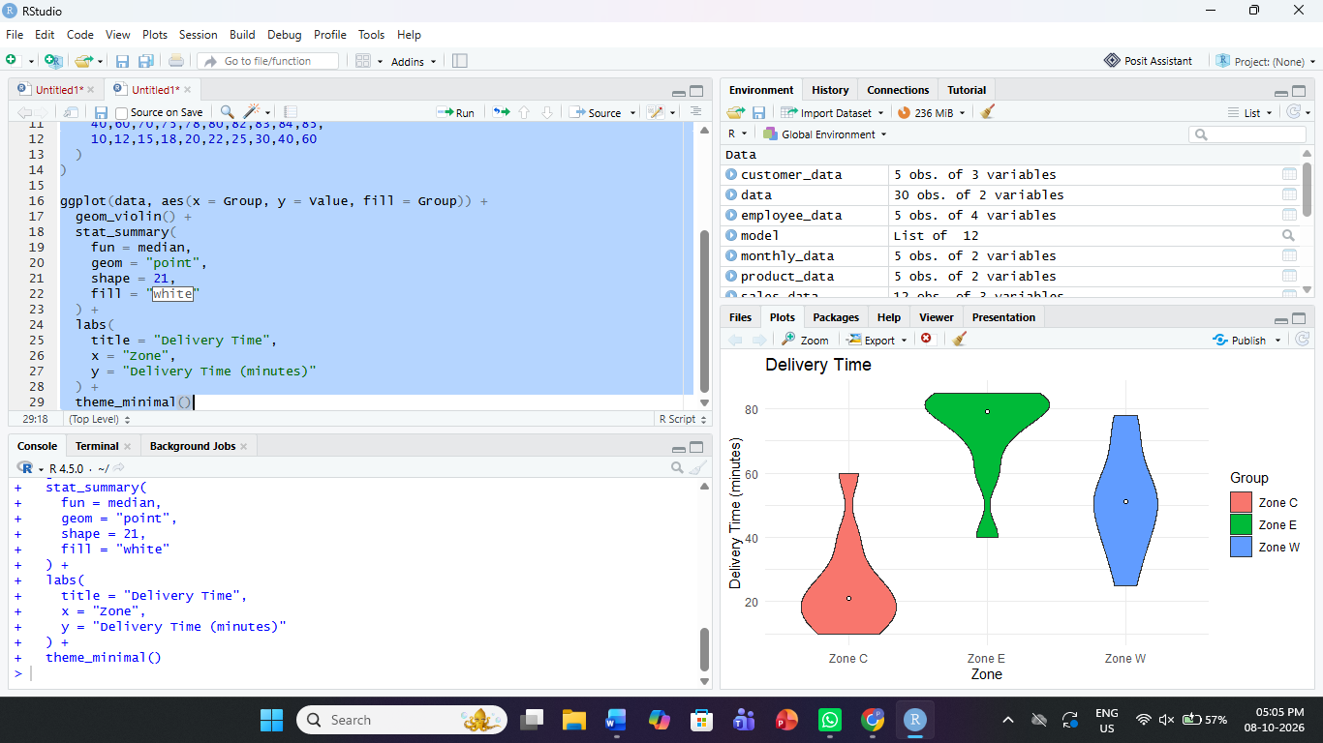
Observation
The shape of each violin indicates the distribution and skewness of the data. A longer tail on the right indicates right skewness, while a longer tail on the left indicates left skewness.
Answers
Violin | Skewness | Mean vs Median
Zone W | Left | Mean < Median
Zone E | Left | Mean < Median
Zone C | Right | Mean > Median

Q2. House Price – Violin Plot
Aim
To identify the skewness of house-price data and determine whether the mean is greater than, less than, or approximately equal to the median.
R Program
library(ggplot2)

data <- data.frame(
Area = c(
rep("Area 1", 10),
rep("Area 4", 10),
rep("Area 3", 10)
),
Price = c(
50,70,85,95,100,105,115,130,145,165,
25,30,35,40,45,50,55,70,100,135,
90,120,150,160,165,170,175,180,190,195
)
)

ggplot(data, aes(x = Area, y = Price, fill = Area)) +
geom_violin() +
stat_summary(
fun = median,
geom = "point",
shape = 21,
fill = "white"
) +
labs(
title = "House Price",
x = "Area",
y = "House Price (Rs lakh)"
) +
theme_minimal()
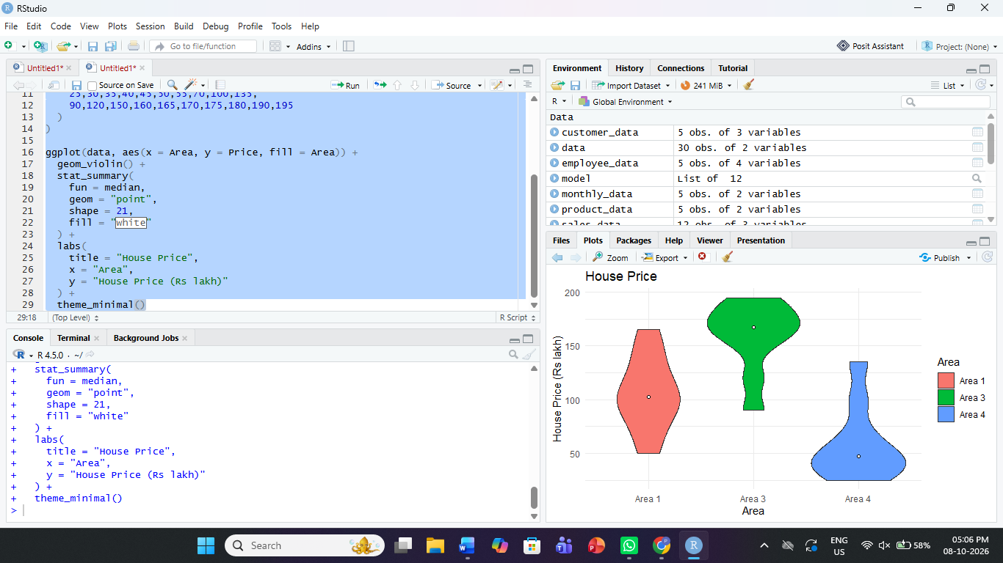
Observation
Area 1 and Area 4 have longer tails toward higher values, while Area 3 has a longer tail toward lower values.
Answers
Violin | Skewness | Mean vs Median
Area 1 | Right | Mean > Median
Area 4 | Right | Mean > Median
Area 3 | Left | Mean < Median

Q3. Commute Distance – Violin Plot
Aim
To analyze the skewness of commute-distance data using violin plots and compare the mean with the median.
R Program
library(ggplot2)

data <- data.frame(
Department = c(
rep("Dept MECH", 10),
rep("Dept IT", 10),
rep("Dept ECE", 10)
),
Distance = c(
6,12,16,18,20,21,23,25,28,35,
14,22,28,31,33,35,36,37,38,39,
1,3,5,6,7,8,10,12,16,25
)
)

ggplot(data, aes(
x = Department,
y = Distance,
fill = Department
)) +
geom_violin() +
stat_summary(
fun = median,
geom = "point",
shape = 21,
fill = "white"
) +
labs(
title = "Commute Distance",
x = "Department",
y = "Commute Distance (km)"
) +
theme_minimal()
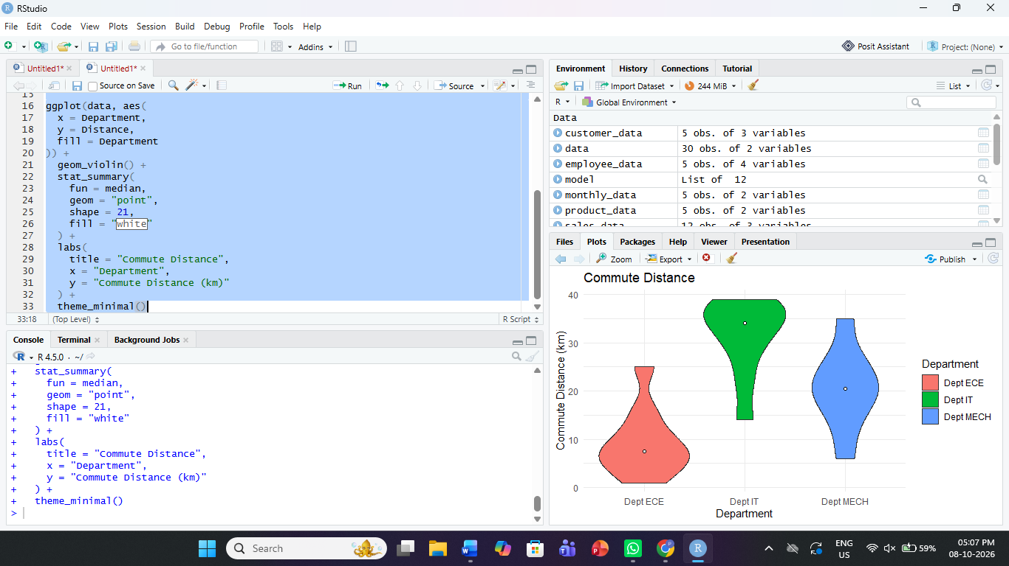
Observation
The distributions show different patterns of commute distance. Dept MECH is approximately symmetric, Dept IT has a longer lower tail, and Dept ECE has a longer upper tail.
Answers
Violin | Skewness | Mean vs Median
Dept MECH | Symmetric | Mean ≈ Median
Dept IT | Left | Mean < Median
Dept ECE | Right | Mean > Median

Q4. Battery Life – Violin Plot
Aim
To identify the skewness of battery-life data for different models and determine the relationship between the mean and median.
R Program
library(ggplot2)

data <- data.frame(
Model = c(
rep("Model P", 10),
rep("Model Q", 10),
rep("Model S", 10)
),
Battery_Life = c(
10,13,15,17,18,19,20,22,24,26,
16,20,22,24,26,27,28,29,29,30,
6,7,8,9,10,10,11,13,16,21
)
)

ggplot(data, aes(
x = Model,
y = Battery_Life,
fill = Model
)) +
geom_violin() +
stat_summary(
fun = median,
geom = "point",
shape = 21,
fill = "white"
) +
labs(
title = "Battery Life",
x = "Model",
y = "Battery Life (hours)"
) +
theme_minimal()
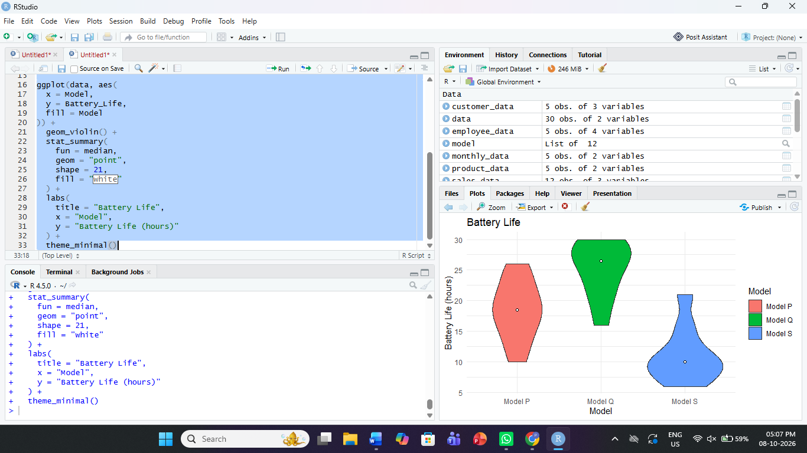
Observation
Model P is approximately symmetric. Model Q has a longer tail toward the lower values, while Model S has a longer tail toward the higher values.
Answers
Violin | Skewness | Mean vs Median
Model P | Symmetric | Mean ≈ Median
Model Q | Left | Mean < Median
Model S | Right | Mean > Median

Part B
B1. Model Q
Answer
Model Q is left-skewed because its tail extends toward the lower battery-life values.
For a left-skewed distribution:
Mean < Median
The median is a better measure of typical battery life because the long lower tail can pull the mean downward. Therefore, the median represents the central battery-life value more reliably.

B2. One ggplot2 line
ggplot(df, aes(x = group, y = value)) + geom_violin() + stat_summary(fun = median, geom = "point", shape = 21, fill = "white")

